**Dog-Gone Industries.**



**Quest**

**Version** **21.678**

**All work copyright 2019 by Dog-gone industries.**

**All rights reserved**

**Table of content:**

-Version history

-Game overview

-Game play mechanics

-Screen Descriptions

-Camera

-Controls

-Interface sketch

-Levels

-Characters

-Enemies

-Weapons

-Items

-Abilities

-Scoring

-Sound index

**Version history:**

This Game design document was made on the 2nd of November, 2019 and will be called version 21.678 (first edition).

**Game overview:**

Quest is 2D Side scroller 90’s Arcade game where players take on the role of Hank an adventurer with a taste for danger tasked with responsibility of completing the obstacle course and making his way home. The ultimate test of skill, maneuverability and hand eye coordination. Players will have to move through the platform, dodging enemies, collecting coins on the way all the while avoiding certain death. Play if you Dare……

**Game play mechanics:**

The playeris able to move using all movement keys (WASD), Spacebar (Jump) as a means of basic movement**.** Players control Hank as they attempt to make it home. Players move through the Platform dodging all Enemies and Pitfalls while making sure to collect as much coins as possible

**Camera:**

Side Scrolling camera

**Controls:**



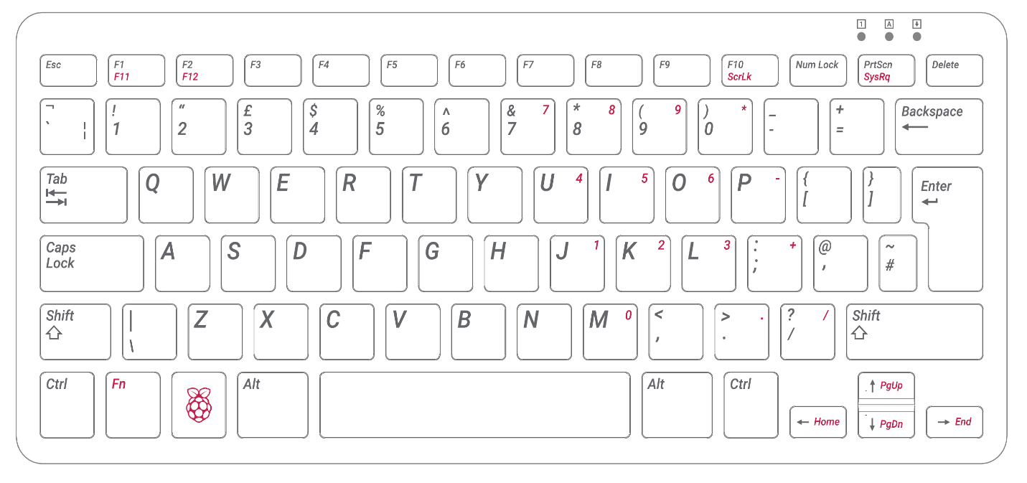



W = Forward/Up-Arrow

A = Left/Left-Arrow

S = Downward/Down-Arrow

D = Right-Right-Arrow

Spacebar=Jump



**Interface Sketch:**

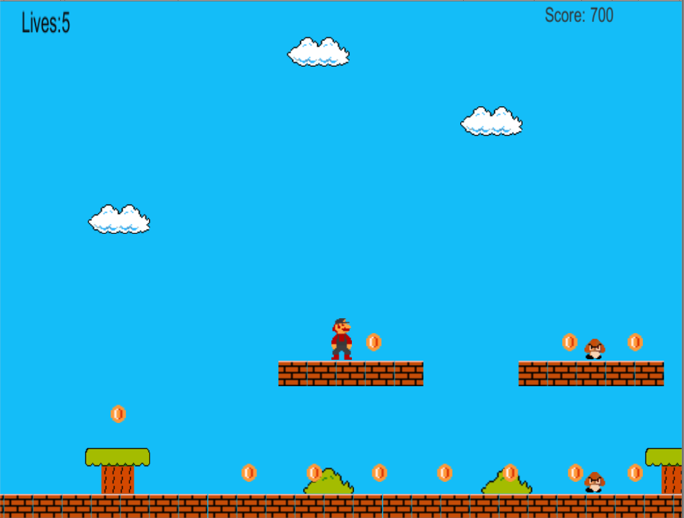

**Screen Descriptions:**

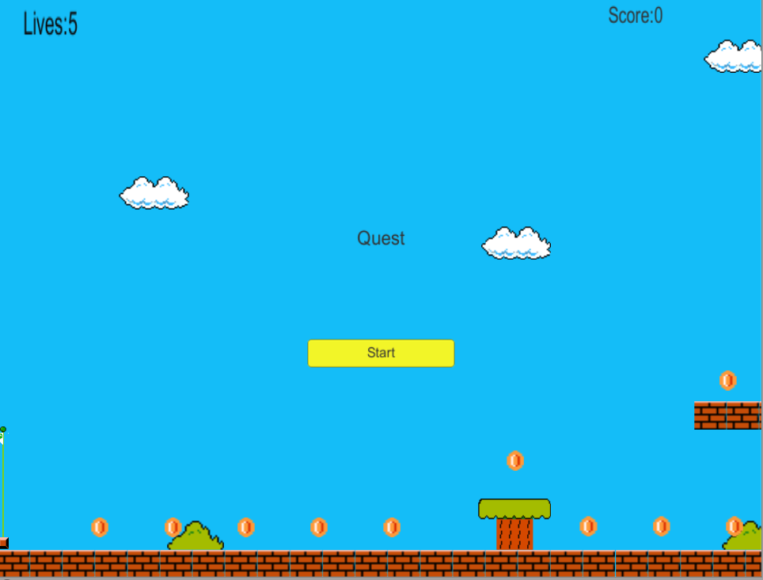

Start screen



Main screen.

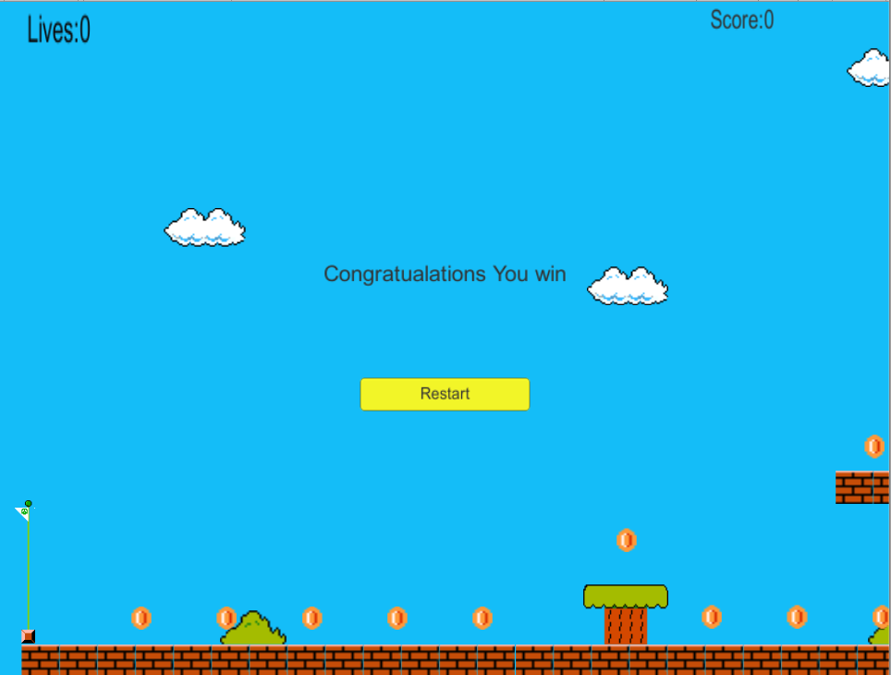

Win Screen

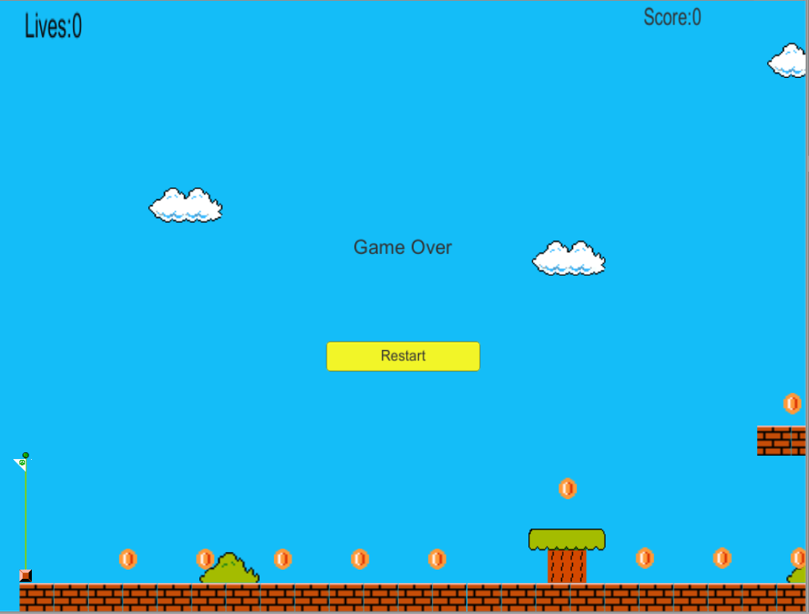

End Screen

**Levels:**

The level follows a progressive increase pattern where it would be designed to pose more of a challenge to the player.

**Characters:**

Players are able to control the character Hank

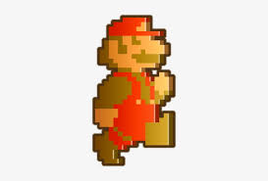

**Enemies:**

The main enemy in the course of the game is the Mushroom troops which the player is required to dodge.

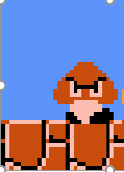

**Items:**

**COINS**

These are the items in which the player collects in order to increase his score.



**Scoring:**

A point of 100 is awarded for each coin collected.

**Sound index:**

A total of 5 soundtracks were used in the game, with each one being assigned to a particular stage in the game.

